Ideation Phase
Empathize & Discover

Date | 31 January 2025
Team ID | LTVIP2026TMIDS76805
Project Name | Online Payments Fraud Detection using Machine Learning
Maximum Marks | 4 Marks

Empathy Map Canvas:
An empathy map helps us understand the user’s thoughts, feelings, goals, and challenges. For this project, we considered two main users:
- Online Payment User (Customer)
- Bank / Fintech Company
Below is the empathy map for an Online Payment User.
Example:
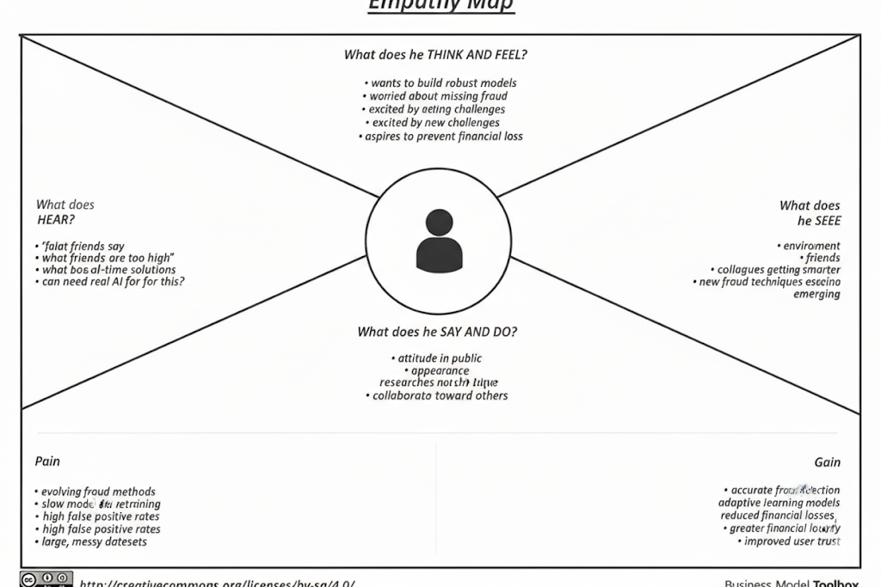

User: Online Payment Customer
What the User Says
- “I want my transactions to be secure.”
- “I don’t want anyone misusing my bank account.”
- “Online payments should be safe and reliable.”
- “I should get alerts for suspicious activity.”
What the User Thinks
- My account details might be stolen.
- Fraud can happen anytime.
- Banks should protect my money.
- I need strong security while making payments.

What the User Sees
- News about increasing online fraud cases.
- Fraud alerts and scam messages.
- Complex security verification processes.
- Payment apps asking for OTP verification.
What the User Hears
- Stories from friends about fraud incidents.
- Bank warnings about suspicious transactions.
- Social media posts about cybercrime.
- Advice to avoid sharing personal information.
User Pain Points (Challenges)
- Fear of losing money.
- Delay in fraud detection.
- Difficulty in recovering lost money.
- Lack of trust in digital platforms.

User Goals
- Safe and secure transactions.
- Instant fraud alerts.
- Protection of personal and financial data.
- Quick action against suspicious transactions.

Example: Online Payments Fraud Detection using Machine Learning
